**LAB 01**

**INTRODUCTION TO CISCO PACKET TRACER**

1. Download the Cisco Packet Tracer **version 8.0** software.

You can download as follows:

Sign in to the Cisco Networking Academy ([www.netacad.com](http://www.netacad.com)). For your account details: see Leho announcement and the email you received some days ago from [noreply@netacad.com](mailto:noreply@netacad.com).

In the homepage, click on the *Resources* menu and choose *Download Packet Tracer*.

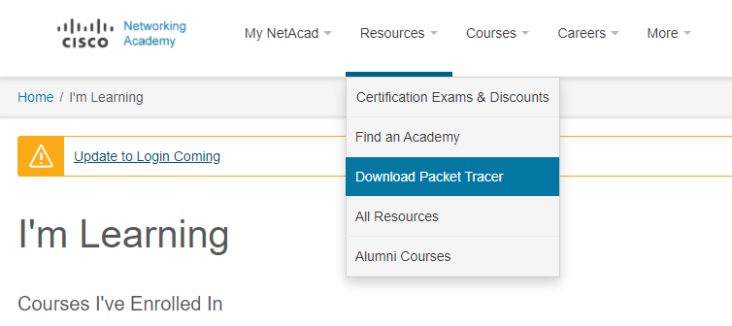

Press the ”**64 Bit Download**“ link under the desired OS.

1. Install Cisco Packet Tracer (from now on referred to as ‘PT’).
2. Start PT.
3. You may get a question for ‘multi-user’ to which you can say ‘yes’. Next, you may get the following security notification. In this window, check both boxes and click on the “Allow Access” button.

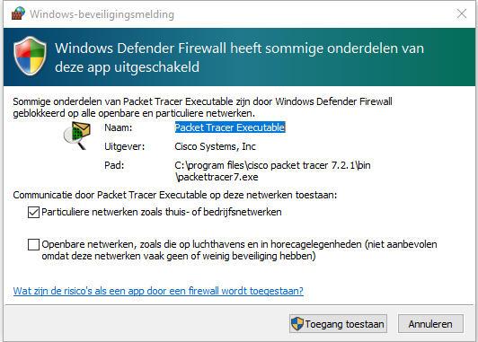

1. Sign in with your Cisco account.
2. Then close PT.
3. Read the “How to access Cisco Networking Academy.pdf” on Leho, in order to know how to access the link in the next step.
4. Surf to <https://contenthub.netacad.com/itn/1.5.7> and click on the download link “Network Representation”. Then open the downloaded PKA file by double-clicking on it.
5. Close the User profile window and PT Activity window.
6. You now see a network consisting of a number of “devices” that are connected to each other by means of “connections”. At the ends of the connections you see a green triangle and/or orange ball representing the interfaces of the devices. The green triangles indicate that the interface is active, while the orange spheres indicate interfaces that are enabled but are not yet active. Normally, after some time, these orange spheres will turn into green triangles.

Tip:To shorten the time you have to wait for the interfaces to activate, press the “Fast forward time” button at the bottom left in PT (this speeds up the “virtual” simulation time).



1. Write for each of the networks below the names of the intermediary devices that appear in it. Also write down how many of these devices are in these networks.
   1. Home Office network: Modem (1), WRS (1)
   2. Central Office: Switch (3 (S1,S2,…), PoE Switch (2 (D1, D2)), Router (1)
   3. Branch Office: Router (1), Switch (1), Access Point (1)
2. In the toolbar under the menu bar, press the “Show Workspace List” button to retrieve the names and models of the devices in the network.

What model is the wireless router in the Home Office network?

Cable-Modem-PT

1. How is the laptop in the Home Office network connected to the router: wired or wireless? How do you know this?

Wireless. The stripes indicate a wireless connection.

1. What is the network name (technical term = SSID) of the Home Office network?

Tip: this is a setting on the wireless router

homeoffice

1. In order for a computer to communicate with another computer, it must have a network card (also referred to as **NIC = Network Interface Card**) to which an IP address was assigned.This address is usually listed as X.Y.Z.U (**dotted decimal notation**) with X, Y, Z and U decimal numbers between 0 and 255. In reality, an IP address is a binary number, consisting of 4x8=**32 bits**. You’ll learn more about this in another lecture.

Write down the IP address of the desktop in the Home Office network below:

**IP address in dotted decimal notation =** 192.168.0.101

Also write down the IP address in binary notation below by converting each decimal number to a 8-bit notation.

**IP address in binary notation =** 11000000.10101000.00000000.01100101

1. An IP address can be configured in two ways: by the (network) manager (static IP address), or by a DHCP server (dynamic IP address).

How the IP address of the desktop’s NIC was configured in the Home Office network: static or dynamic?

The desktop’s NIC is configured as a static IP

1. In addition to an IP address, a NIC also has a “baked-in” MAC address, which in principle cannot be changed. Again, more on this in another lecture. At Cisco, this is recorded as 3 groups of 4 hexadecimal digits, separated by a point.

So how many bits does that MAC address consist of?

48 bits

Write down the MAC address of the desktop in the Home Office network below:

**Mac address in CISCO notation =** 0004.9A64.227D

Note below how this MAC address (= Physical address) would be recorded in Windows.

**Mac address in Windows notation =** FE80::204:9AFF:FE64:227D

Hint: If you don't know the Windows notation, type the Windows command   
ipconfig /all in the command prompt of your laptop (not PT).

Below also write down the MAC address in binary notation by converting each hexadecimal number to a 4-bit notation. Do the calculations without a calculator!

**Mac address in binary notation =** 1111111010000000::1000000100:1001101011111111: 1111111001100100:10001001111101

1. Please write down below about the NICof the desktop in the Home Office network:

**Speed (bandwidth) = 100 Mbps**

**Half or full duplex?** Full Duplex

1. Check if there is network connection between the laptop and desktop in the Home Office network. You can do this by pinging from the command prompt on the laptop to (the IP address of) the desktop. Below, write down the command you used for this.

**Command =** ping 192.168.0.101

The ping command sends a number of test packets to the other computer, which answers it (if there is a connection).

How many packets are sent by the ping command by default?

**Number of packets =** 4

How big are those packets?

**Size ping packets =** 32 bytes

1. Check if there is network connection between the laptop in the Home Office network and the server in the Central Office network. Write down the command you entered on that laptop.

**Command =** ping 10.10.10.2

1. Check if you can surf from the laptop in the Home Office network to (the IP address) of the server in the Central Office network.

What makes you think this doesn't work?

Http is not turned on yet

Change the configuration of the server so that you can.

Tip:use the “Services” tab.

Check if you can surf after that.

1. Check if the IP address of PC1 in the Central Office network is a static or dynamic IP address.

Dynamic adress

Was this IP address assigned by the CentralServer?How do you know this?

No, CentralServer is not configured as DHCP server

How can you find out the ip address of the DHCP server?

Ipconfig /all

1. For a wired connection, add a desktop PC to the Home Office network and enter your first name as your name.

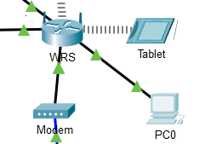

Make sure you can make a network connection to the wireless router by assigning a dynamic IP address (i.e. via DHCP) to that PC.

Below, write down the IP address that was automatically assigned to that PC.

**IP address =** 192.168.0.103

Note that the wireless router (as a DHCP server) has not only distributed an IP address to that PC. Which 3 settings were also automatically configured by that router? (this will be discussed further in the course)

* Subnet mask
* Default gateway
* DNS server

1. Save the modified PKA file under the name **lastname-firstname-lab01.pka (**in which you replace lastname and firstname of course with your own last name and first name) and upload it via Leho.